CS 255 System Design Document
Jessica Paul

UML Diagrams

UML Use Case Diagram
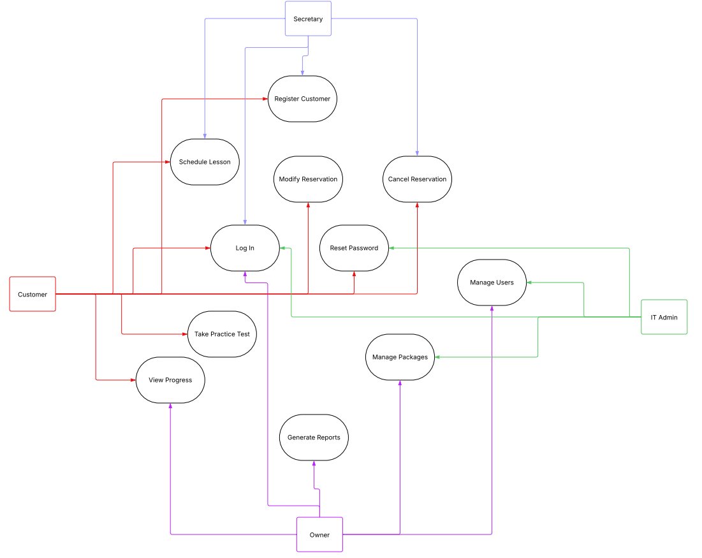

UML Activity Diagrams
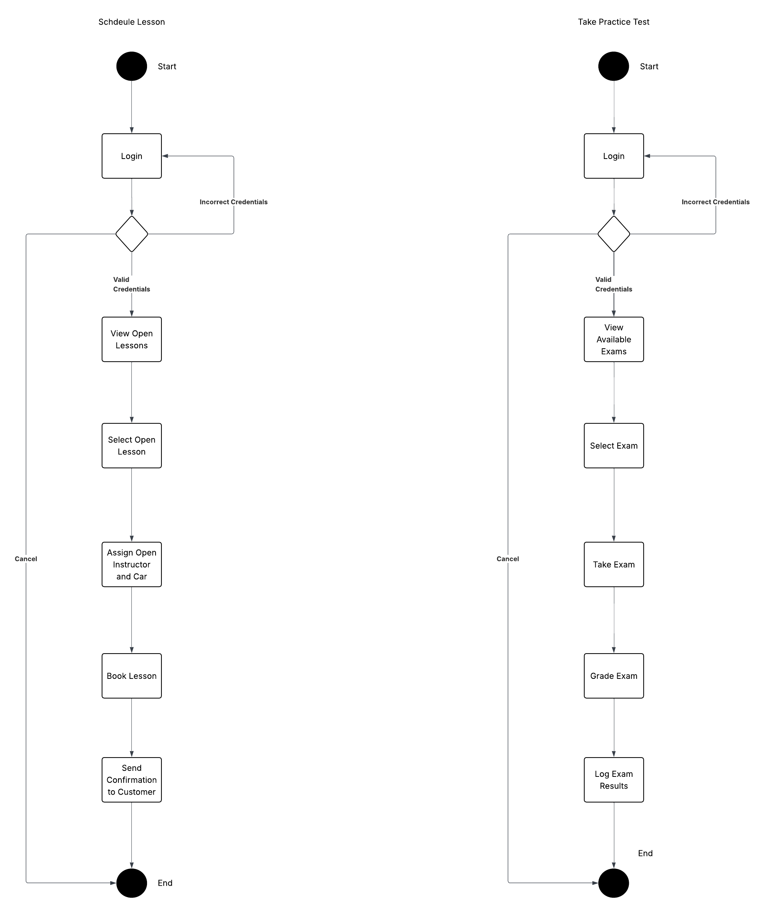

UML Sequence Diagram
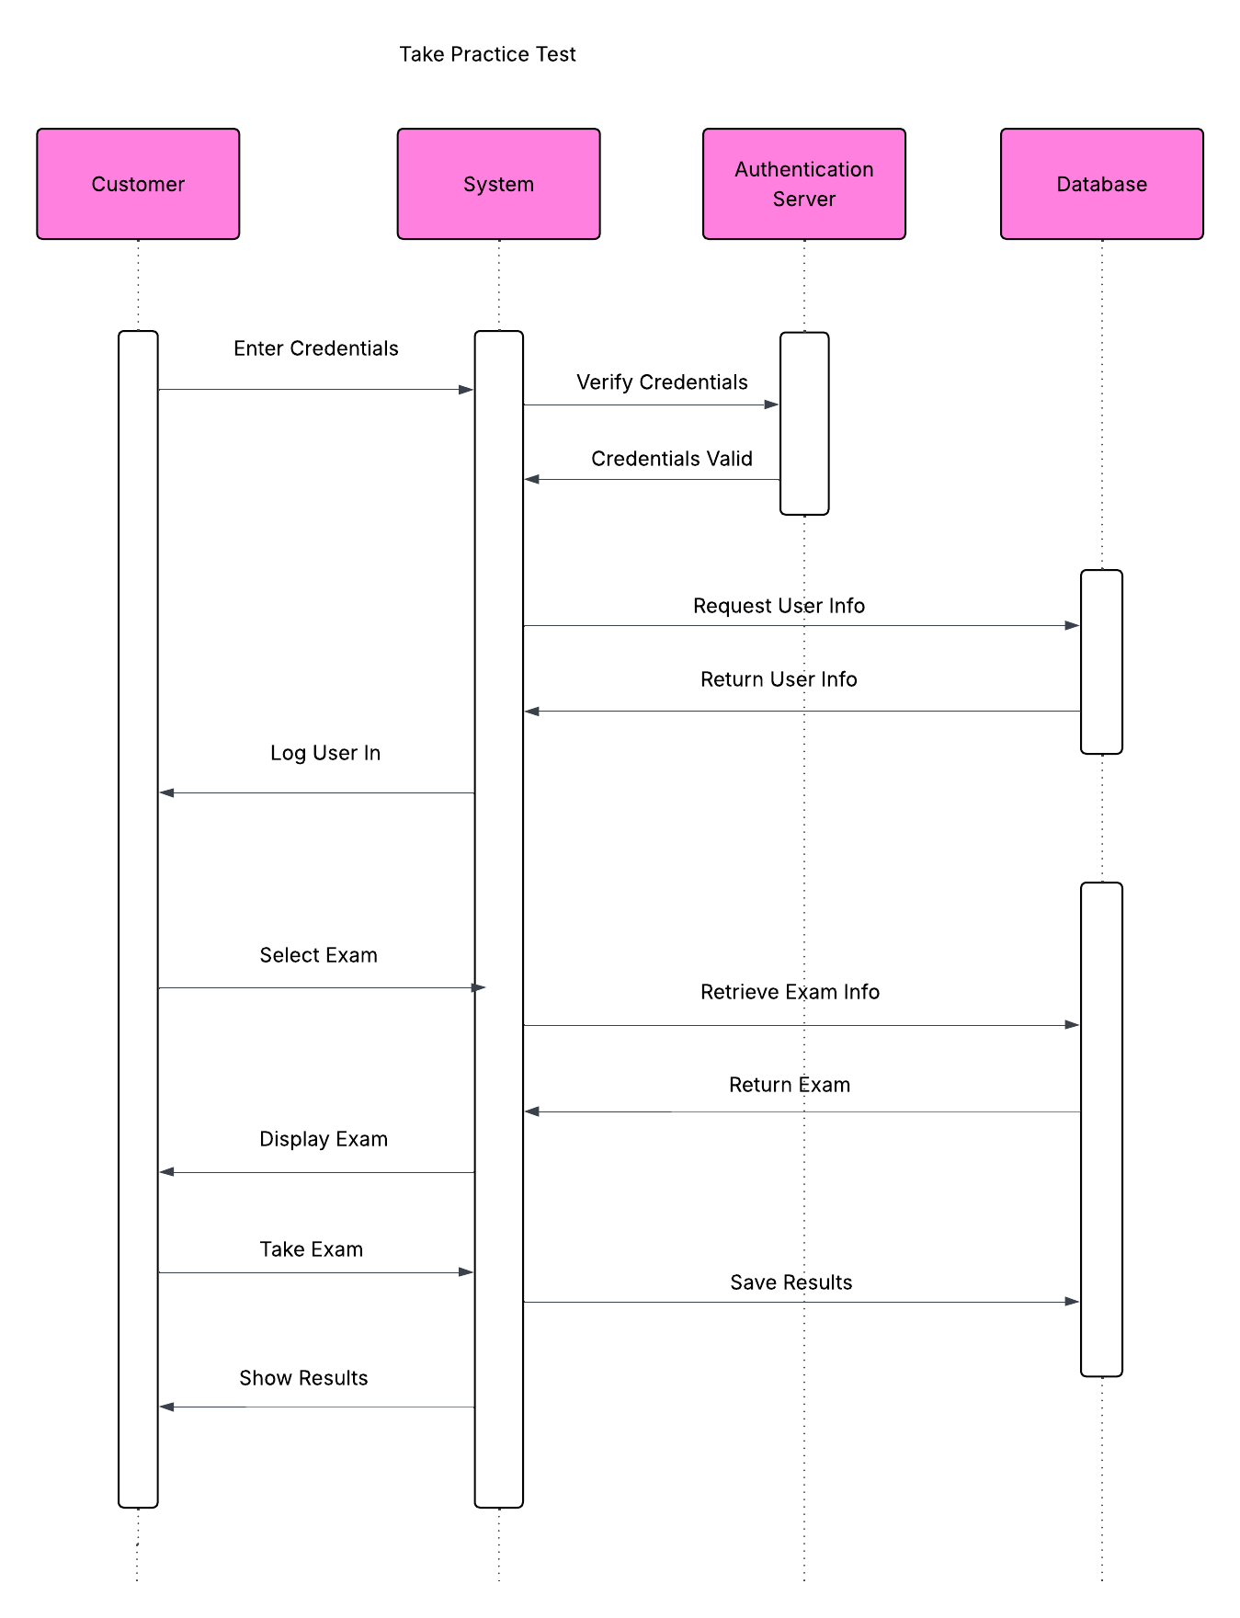

UML Class Diagram
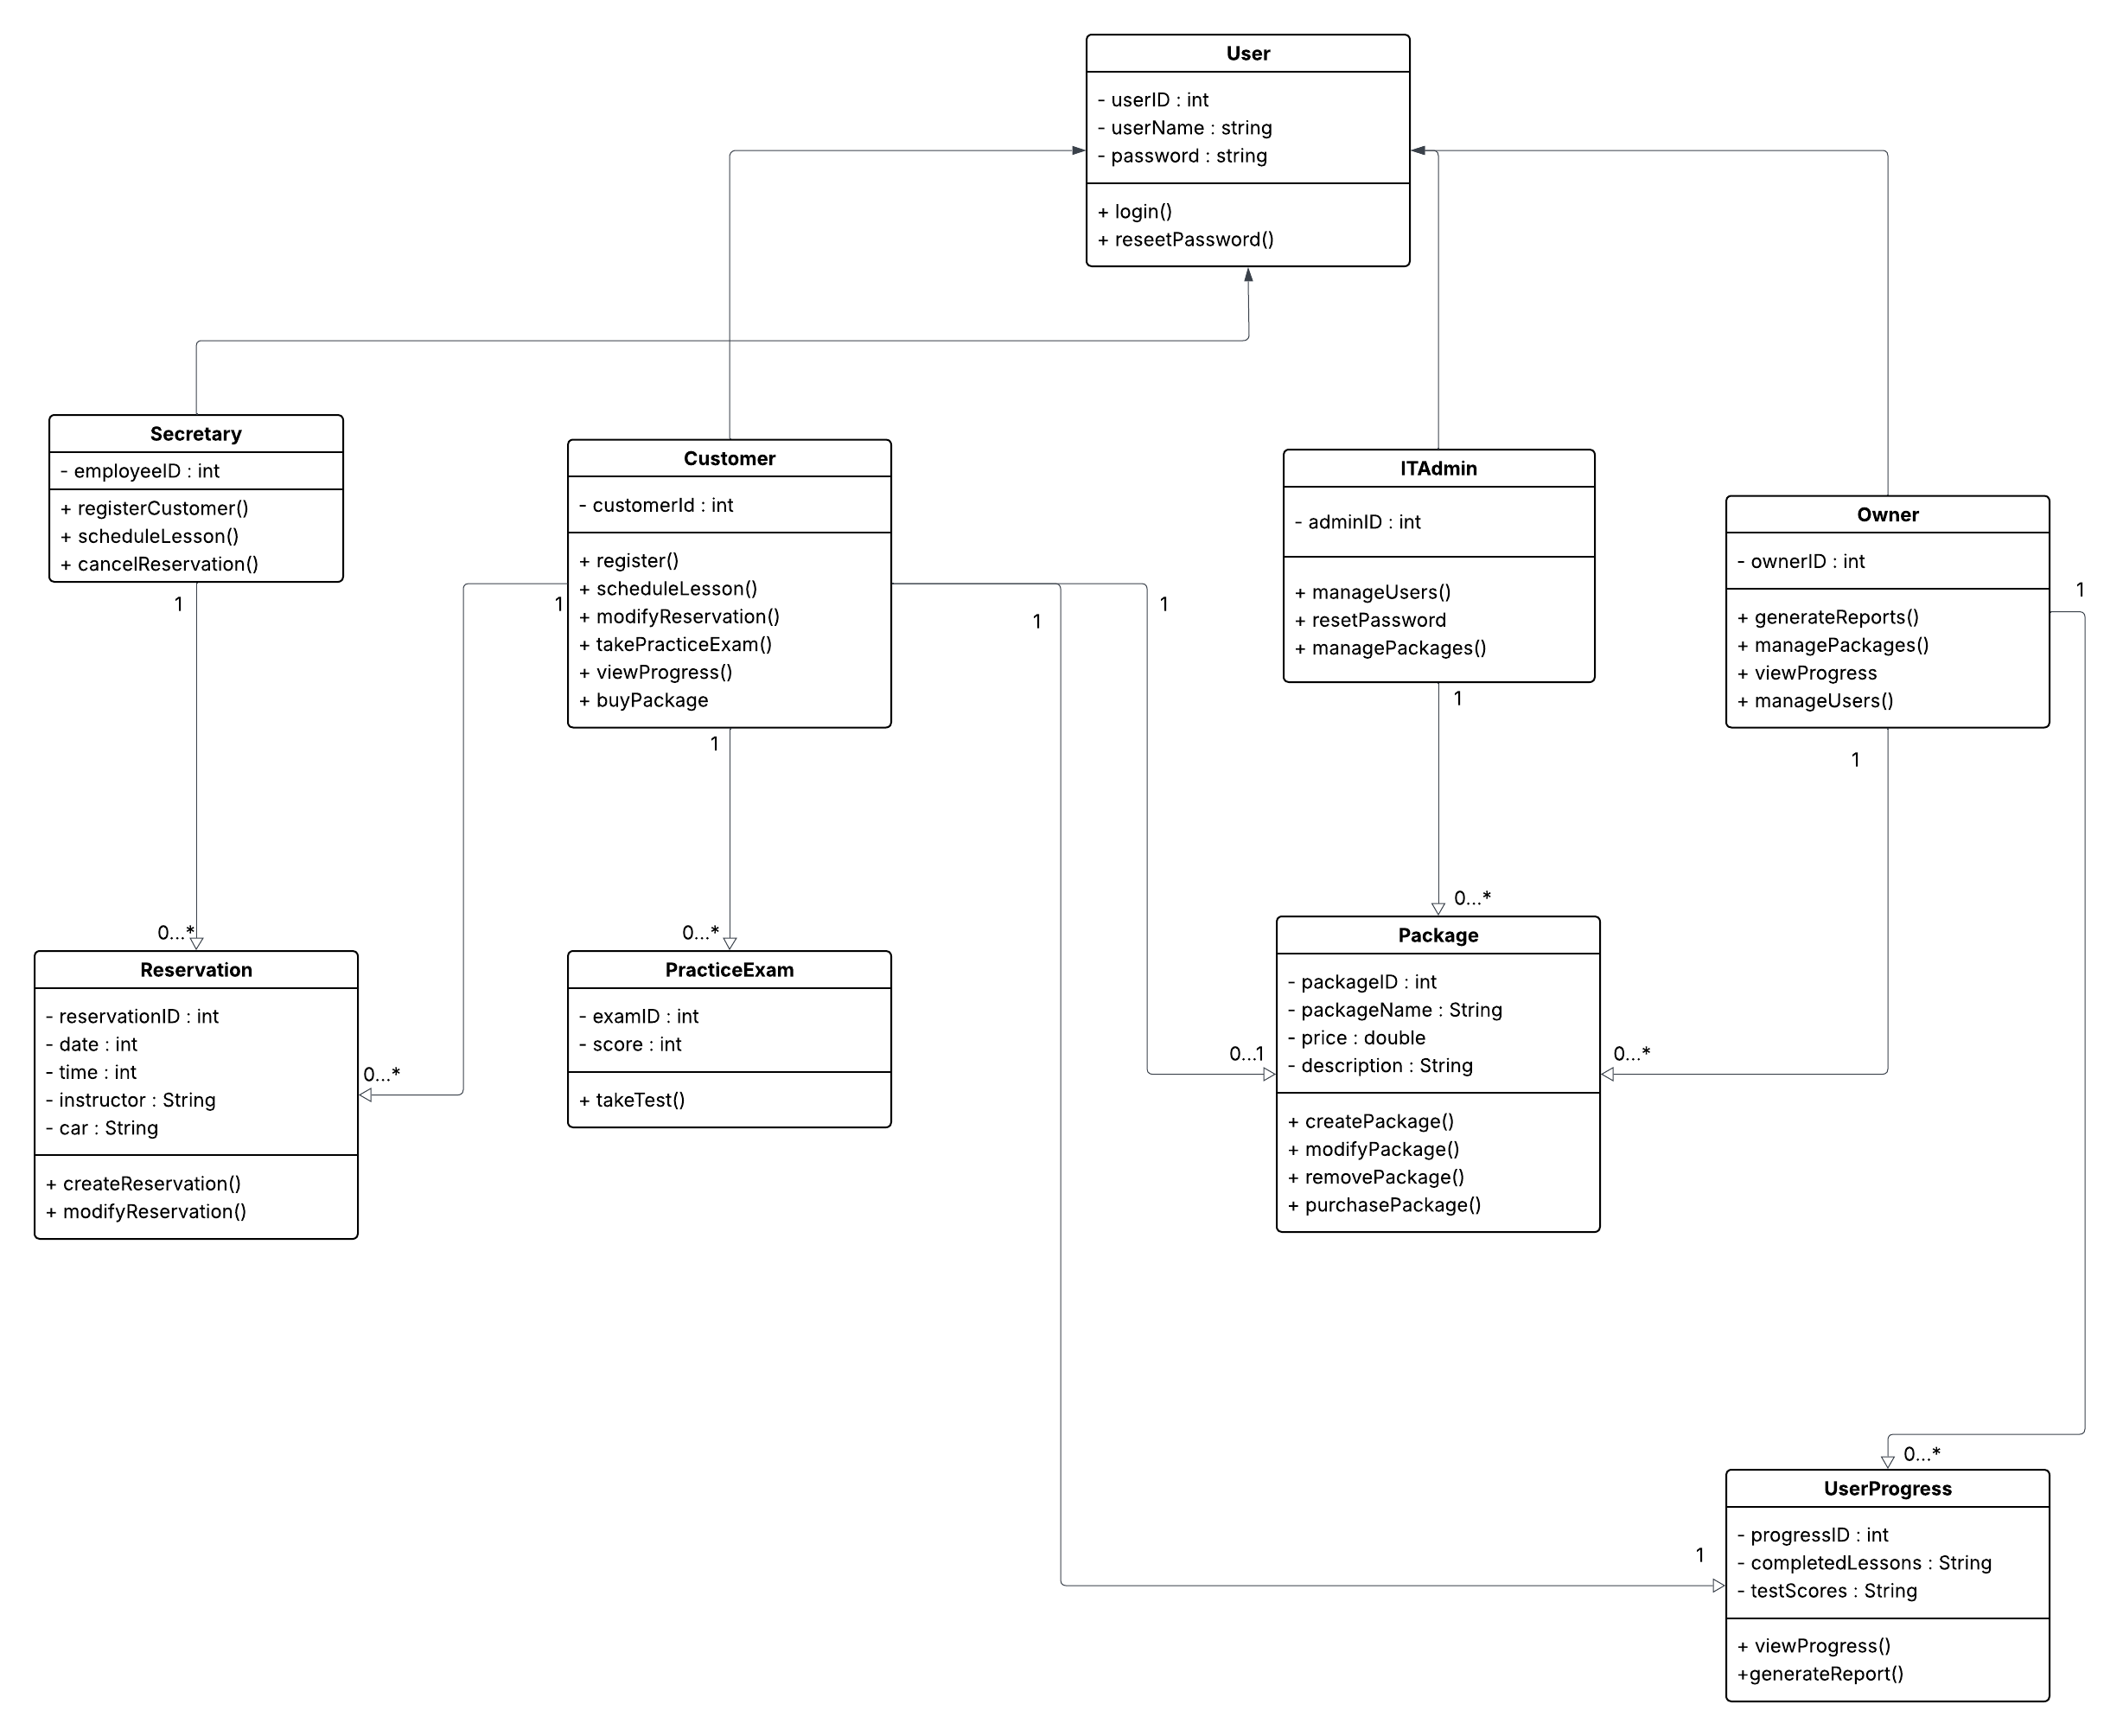

Technical Requirements

There are several technical requirements to consider when creating this web application. First, it needs to be run on a cloud-based server. We need to minimize latency while maximizing performance as we set it up. We need to create a backend database for the system that will contain accounts, schedules, progress, packages, etc.... We need to create some form of user authentication with role-based access to ensure safety of the customers and correct permissions based on user type. We need some sort of password recovery for when users forget their passwords so that they don’t lose their accounts. Admins should be able to update the system without needing to modify the source code to ensure they can continue to use and update the system long after we create it. Making sure we meet all these requirements will ensure that DriverPass has both a successful launch and a successful future.

